KSE Software JSC
Office Renting
User Documentation

- Introduction
This website was created to launch an online office rental service. The website allows login access to the central management system. It provides the central manager with the ability to edit and assign permissions to different personnel within the website, as well as the ability to create management accounts for different departments of the site. Additionally, it features user verification through OTP sent via personal email. The website also includes a messaging function between managers and a dedicated notification system for messages within the site.
Tools Requirement:
- VS Code ( Visual Studio Code)
- Xampp
- Web Browser
- Postman
- Getting Started
To begin using the online office rental service website, follow the steps below:
- Install Required Software
  - Download and install VS Code (Visual Studio Code) for code editing.
  - Install XAMPP to set up the MySQL database and PHP server.
  - Ensure you have a compatible web browser (e.g., Google Chrome, Mozilla Firefox).
- Clone the Project Repository
  - Clone the project files from Github by running the code: git clone https://github.com/103806560/IT-project
- Set Up the Front-End
  - Navigate to the front-end directory of the project using a terminal.
  - Run commands to install the necessary dependencies:
npm install @emotion/react@^11.13.3
npm install @emotion/styled@^11.13.0
npm install @mui/icons-material@^6.1.6
npm install @mui/material@^6.1.6
npm install @testing-library/jest-dom@^5.17.0
npm install @testing-library/react@^13.4.0
npm install @testing-library/user-event@^13.5.0
npm install axios@^1.7.7
npm install bcrypt@^5.1.1
npm install bootstrap@^5.3.3
npm install chart.js@^4.4.6
npm install cors@^2.8.5
npm install express@^4.21.1
npm install react@^18.3.1
npm install react-char
npm install react-chartjs-2@^5.2.0
- Set Up the Back-End
  - Navigate to the back-end directory of the project using a terminal.
  - Run commands to install the required dependencies:
npm install bcrypt@^5.1.1
npm install chart.js@^4.4.6
npm install cors@^2.8.5
npm install crypto@^1.0.1
npm install dotenv@^16.4.5
npm install express@^4.21.1
npm install jsonwebtoken@^9.0.2
npm install multer@^1.4.5-lts.1
npm install mysql2@^3.11.3
npm install nodemailer@^6.9.16
npm install react-chartjs-2@^5.2.0
- Set Up the Database
  - Open XAMPP and start the MySQL and Apache services.
  - Import the “kse_office_rentals” database into phpMyAdmin.
  - Ensure the database credentials match those specified in the .env file of the project.
  - Create a table using SQL statement:
    - Table notifications
    - Table messages
    - Table users
- Run the Project
  - Start the back-end server:
npm start
  - Start the front-end development server:
npm start
- Open the website in your web browser using the URL:http://localhost:3000
- Create Super Admin account
  - Run Postman
  - Paste URL: http://localhost:5000/create-superadmin
  - Navigate to the Body paste the code below and change the flowing information with your own:
{
"username": "admin",
"password": "1234",
"email": "abc@gmail.com"
}
- Keep Secure
  - Delete superAdminCreate.js in the project file to keep secure for the admin systems.
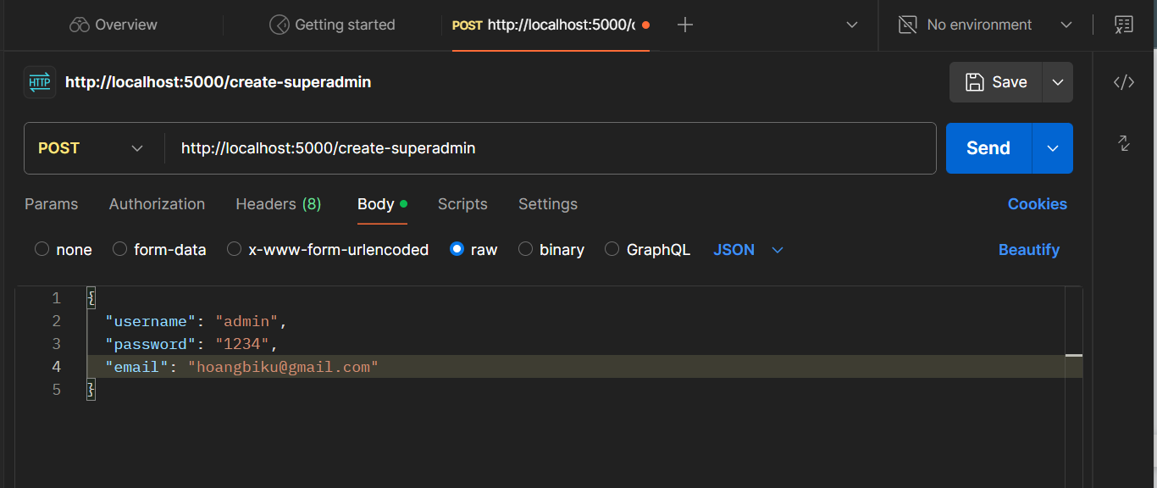
Figure 0: Create Super Admin account
- Features and Functionalities
- User Login
  - Secure login system.
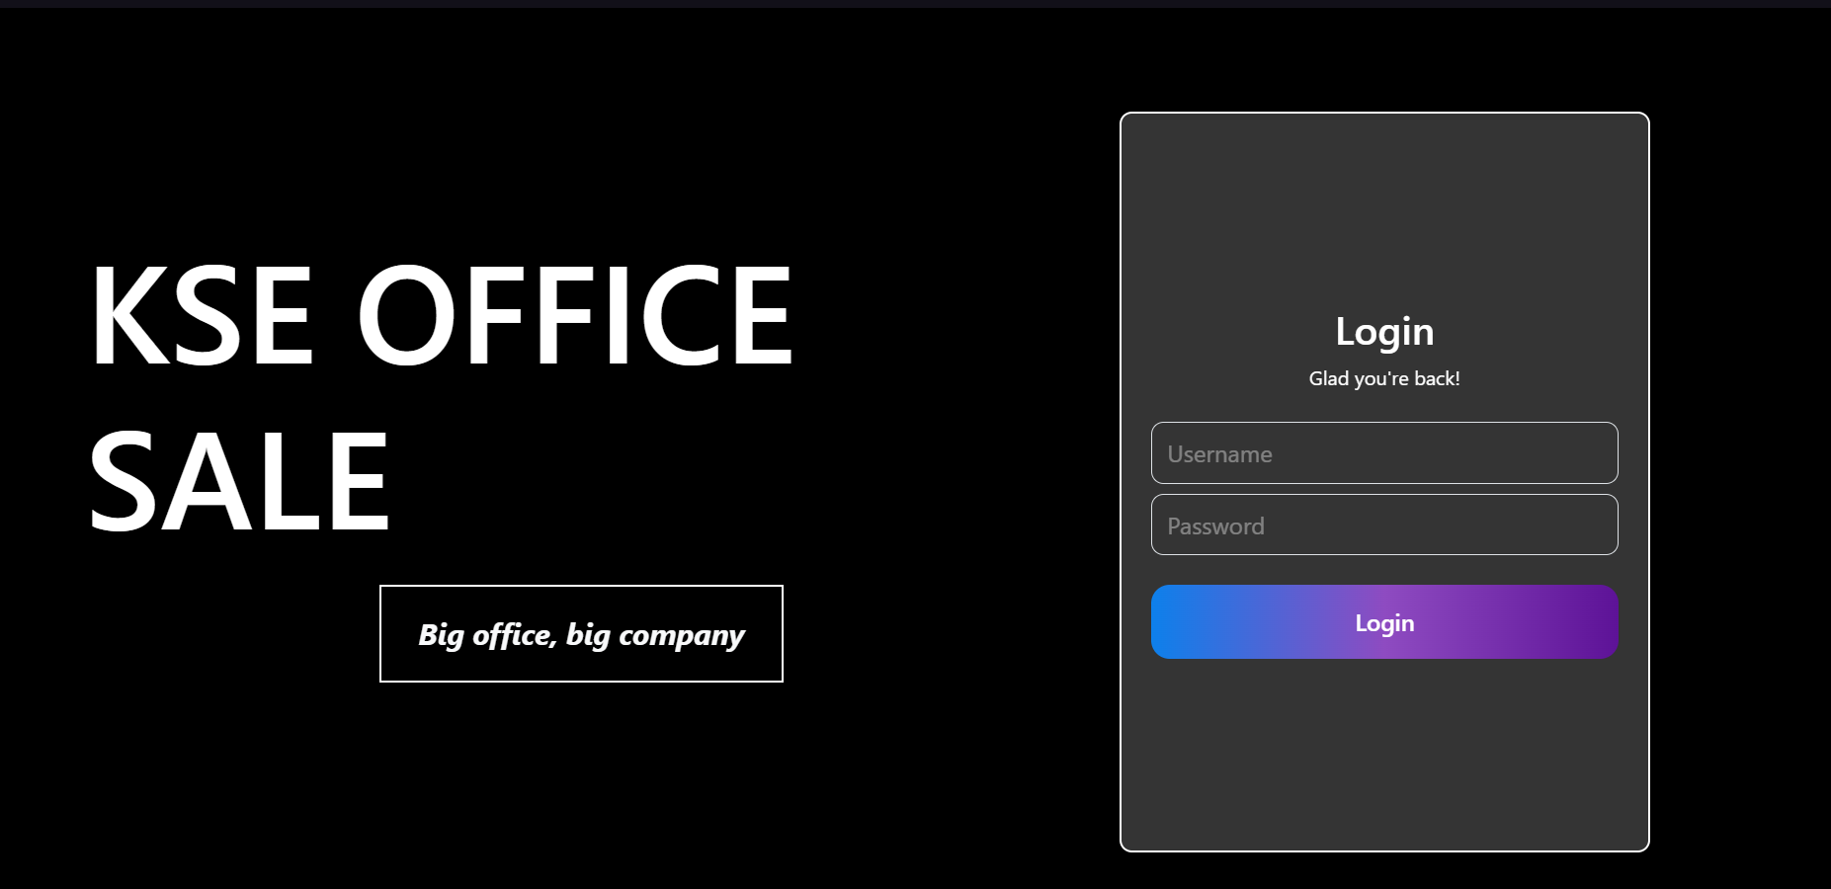
Figure 1: User Login
- Role-Based Access Control (RBAC)
  - The central manager assigns roles (e.g., Super Admin, Admin, Finance Admin) and staff permissions.
  - Each role has specific access to features like managing accounts, viewing analytics, and office data.
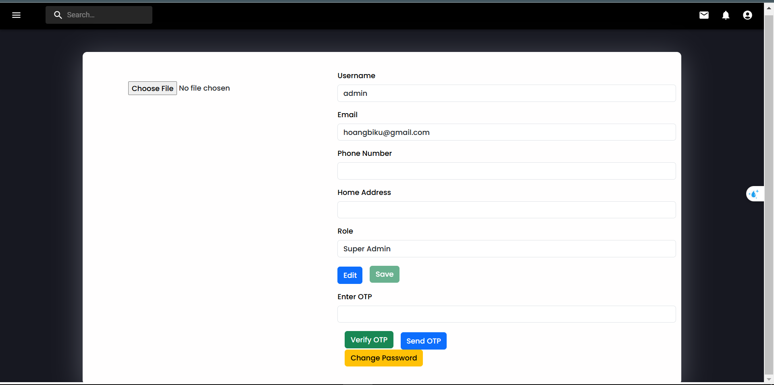
Figure 2: Role-Based Access Control (RBAC)
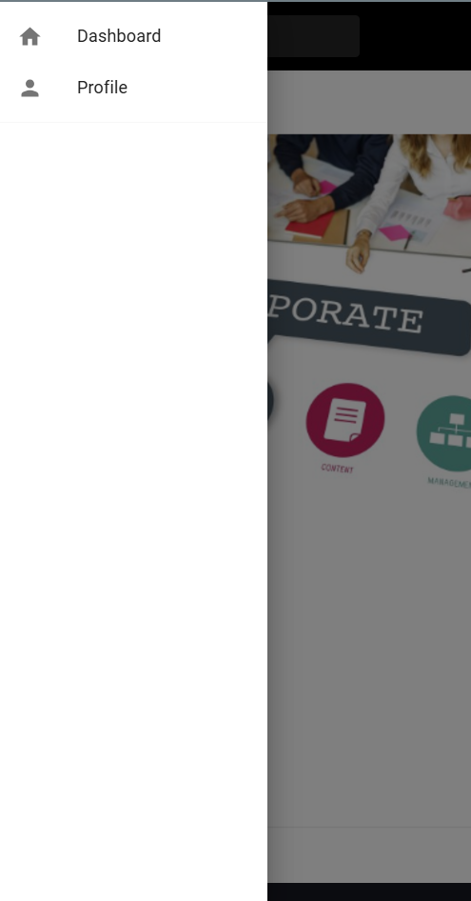
Figure 2.1: Menu for non-verify account
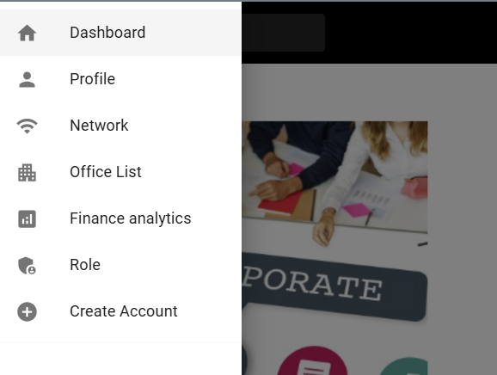
Figure 2.2: Menu for Super Admin
- Notifications and Messaging
  - Built-in messaging system for every admin to communicate securely.
  - Notification system to alert users of important updates.
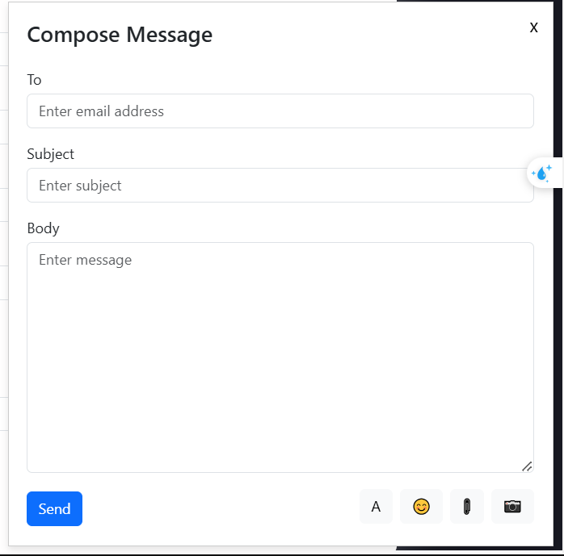
Figure 3: Messaging


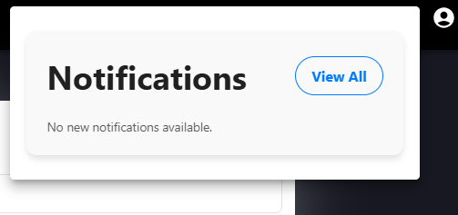
Figure 4: Notifications
- Secure OTP Verification
  - OTP-based email verification for secure access to specific staff permissions, features, notifications, and messages,...

Figure 5: OTP Verification
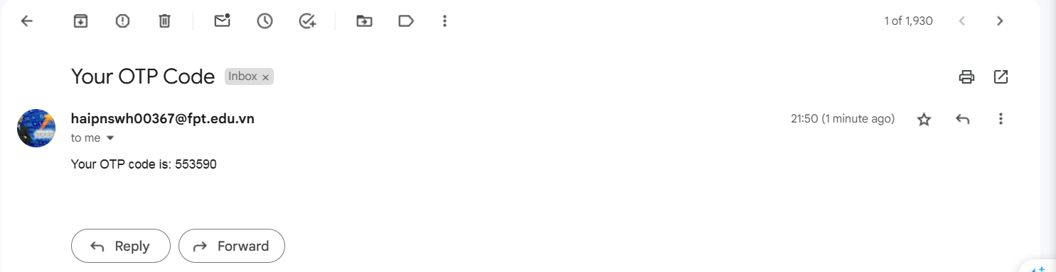
Figure 5.1: OTP Sent to Email
- Advanced Features
- Super Admin Management
  - The Super Admin can dynamically create admin accounts for different departments.
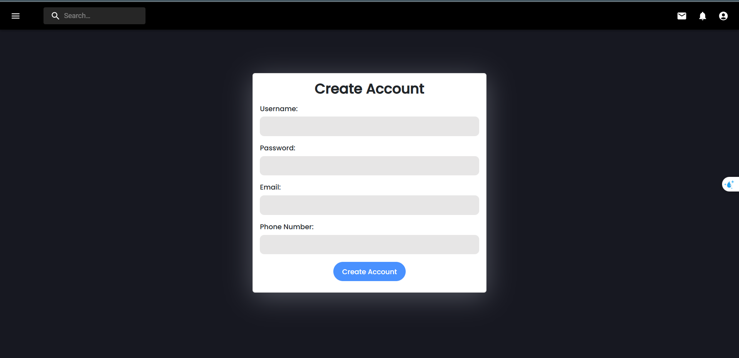
Figure 6: Create Account

- Secure Messaging and Notifications System
  - Integration of a secure messaging system that stores messages in two MySQL tables: notifications and messages.
  - Notifications are displayed in a summary view (via the bell icon) and a detailed view (via the notifications page).

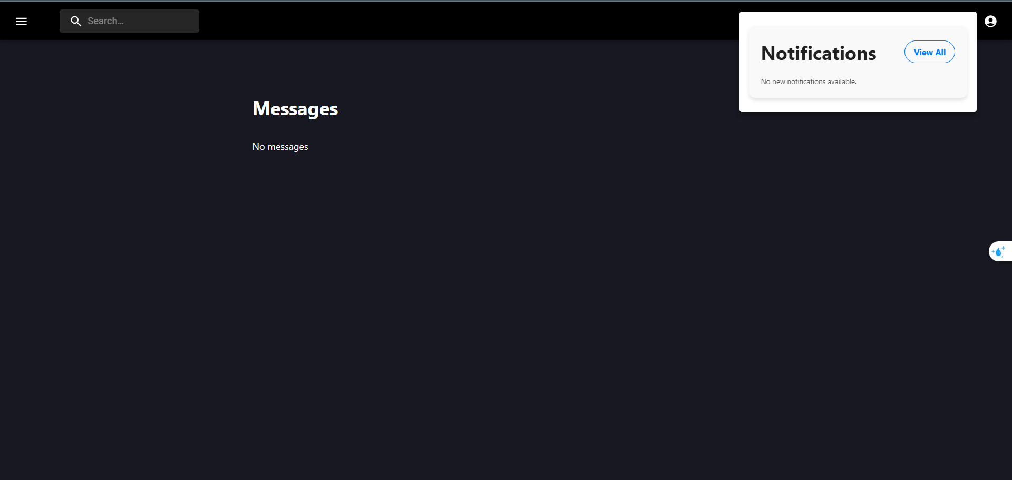
Figure 7: Summary view and detailed view

